A STUDY ON CUSTOMER SATISFACTION ON BAIDYA NATH

INDEX

CH NO. | CHAPTER NAME | PAGE NO.
1 | INTRODUCTION | 1
2 | INDUSTRY PROFILE | 5
3 | COMPANY PROFILE | 16
4 | OBJECTIVE OF STUDY | 26
5 | RESEARCH METHODOLOGY | 28
6 | THEORETICAL BACKGROUND OF THE STUDY | 31
7 | DATA ANALYSIS AND INTERPRETATION | 38
8 | FINDINGS | 53
8 | SUGGESTIONS | 56
10 | CONCLUSION | 58
 | BIBLIOGRAPHY | 60
 | QUESTIONNAIRE | 62

CHAPTER NO.1
INTRODUCTION

WHY THIS TOPIC IS IMPORTANT ?
Ayurvedic medicine aims to integrate and balance the body, mind, and spirit. This balance is believed to lead to happiness and health, and to helpprevent illness. Ayurveda offers methods of finding out early stages of diseases that are still undetectable by modern medical investigation. Most of our Indians not going for Ayurvedic Medicine. The people who arecoming from the Ayurveda background only come to know the importance of medicine. But the fact is that it includes several key functions in Ayurvedic disease treatment. Ayurveda understands that health is a reflection of when a person is living inharmony with nature and disease arises when a person is out of harmony with the cycles of nature.
All things in the universe (both living and nonliving) are joined together in Ayurved Ayurvedic medicine originated in India and have been used from our ancienttimes. In the United States, Ayurvedic medicine is considered complementary and alternative medicine (CAM), and its rise in popularity throughout the world. In the second millennium BC, Ayurveda is found in the Rigveda and the Atharveda. Ayurveda is spread throughout Tibet and China by Buddhist monks. Many Chinese scholars visited India and even studied in ancient Indian universities. In medieval times, the Arab world became a hub of international science and medicine. Ayurvedic medicine continues to be practised in India. It is also practised in Bangladesh, Sri Lanka, Nepal, and Pakistan. The oldest medical book in the world is Atreya Samhita

BRIEF ABOUT THE COMPANY
Baidyanath Group is an Indian pharmaceutical firm specialising
in Ayurvedic medicines.^{[1]} Shree Baidyanath Ayurved Bhawan (Pvt) Limited was founded in 1917 by two brothers, Vaidya Pandit Ram Narayan Sharma and his brother Pandit Ram Dayal Joshi with a vision of providing effective and readily available medicines to the population of India.
Pandit Ramnarayan Sharma, an illustrious practitioner of Ayurveda, made a small beginning by starting the manufacture of Ayurvedic medicines at Baidyanath Dham in Bihar in the year 1917 and then pioneered a large scale production of Ayurvedic formulations with his brother at:
Kolkata in 1921
Patna in 1940
Jhansi in 1941
Nagpur in 1942
Prayagraj in 1958
Under the flagship of Shree Baidyanath Ayurved Bhawan, this expansiondid not prove sufficient, and a new work came up at Baddi (Solan),Himachal Pradesh in the year 1995. Now, new plants exist at Barotiwala (Himachal Pradesh), Kashipur (Uttarakhand),and Seoni (Madhya Pradesh). The current Managing Director Of BaidyanathGroup is Shri. Ram K Sharma at Kolkata and Shri. Suresh Kumar Sharma atNagpur.
In 2017, the group completed 100 years and decided to foray into the FMCG market with the introduction of new products like Amla, Aloe vera Karela Jamun, Giloy varieties, and Herbal Tea. The age-old ayurvedic brand not only sells its products through offlinechannels, but also through various online platforms. During COVID- 19 times, Baidyanath’s participated in one of the

biggest online events, Amazon’s Prime Day, to ensure that some of their best immunomodulators seamlessly reach their customers’ doorsteps with the helpof Amazon.^{[4]} Also, the demand for this brand’s ayurvedic productsincreased during the COVID phase, especially for immunity boosters such asGiloy, Giloy Batti, and Chyavanprash. Baidyanath Group awarded 1.5 lakh INR for the best research paper or bookon Ayurveda every year during 2016-19.^{[6]} The group also facilitated the practitioners of Ayurveda as a part of Dhanwantari Jayanti"The one thing you're putting off or dreading? That's your brain telling you it's the thing you need to do most and next. Get it done. Stop dreading. Do."-Nancy Nardin. A sales promotion is a marketing strategy in which a business uses atemporary campaign or offer to increase interest or demand in its product or service. There are many reasons why a business may choose to use a sales promotion(or 'promo'), but the primary reason is to boost sales. Sales promotion Strategy As we've seen, sales promotions come in a large variety and can be used as asales strategy at any point during the sales process. It's important, therefore, .Align your sales promotion with your company: Consistency is always keyin every aspect of sales, and it's no different with a sales promotion. If you specialize in long-term products, such as electronics, then it doesn't make sense to offer customers a subscription package when they're only going

BREIF ABOUT THE MY PROJECT

This is the project on shree baidyanath ayurvedic bhawan pvt ltd.ittotally deals with ayurvedic medicines, the place where I worked medicines were manufactures and there my work was to take the feedback from the medical shop venders

CHAPTER NO. 2

INDUSTRY PROFILE


WORLD SCENERIO
Global Ayurvedic Market was worth US$ 8.83 Bn. in 2021 and overall revenue is anticipated to rise at a rate of 15.63% from 2021 to2029, reaching almost US$ 21.12 Bn in 2029.

Global Ayurvedic Market Overview:
People are becoming more aware of the adverse effects of allopathic treatments, so the Ayurvedic market is growing at a CAGR of 15.63% over the forecast period. A favorable impact aspect on market growth is also the ease of availability and increased awareness of the products' benefits. Expanding medical tourism is helping to boost the market's growth. The

research on the global Ayurveda industry includes a comprehensive analysis of the market for the forecast period. The report includes several sections as well as an analysis.

Global Ayurvedic Market Dynamics:

Some of the factors driving market growth include rising demand fornatural and organic products, higher consumer knowledge and desire for ayurvedic cosmetics, and increased medical tourism around the world. Organic skincare is gaining popularity, and the market is likely to expand even further. Anti-wrinkle and anti-aging creams are also expected to expand the market in order to reach a wider audience. Dueto an increase in medical tourism, the global market is expected to grow. Certain constraints and barriers have been encountered, which will limit market expansion. Lack of optimal treatments, a lack of a killer instinct in the ayurveda business, and severe regulations are all significant limitations to the worldwide Ayurvedic Market's overall growth. Nonetheless, technological advancements, practical breakthroughs in ayurveda treatment, and untapped potential in new countries all present good growth prospects.

Global Ayurvedic Market Segment Analysis:
Global Ayurvedic Market is segment into Mode of sales, Product, Application and Distribution channel. Based on Product, the market is sub-segmented into Personal Care Products, Hair Care & Fragrances, Skin Care, Oral Care, Make-Up, Healthcare Products, Ayurvedic Medicines, Ayurvedic Nutraceuticals, and Dietary Supplements. The personal care products segment is driving the ayurveda market globally, owing to increased knowledge of personal care products, changes in consumption

patterns and lifestyles, and enhanced women's purchasing power, which all point to the personal care industry moving forward. Due to the presence of established Ayurvedic manufacturing facilities. Based on the Distribution channel, the market is sub-segmented intoSupermarkets, Pharmacy & Drug Stores, Direct Selling, Beauty Salons,Specialty Stores, Internet Retailing, Departmental Stores, and Other Distribution Channels. During the forecast period.

Global Ayurvedic Market Regional Analysis:
As the world's innovator and origin of Ayurvedic medicines markets, Asia Pacific, particularly India, is expected to be the dominant market in the global Ayurvedic medicines market. The global Ayurvedic medications market will expand as local and global Ayurvedic medicines manufacturers in India and other areas implement technology advancements. Due to the major global players' increasing offerings of Ayurvedic medicines and other herbal products, the Ayurvedic Medicines markets in South and East Asia are expected to rise at a considerable CAGR. Ayurvedic medicine has the potential to improve global population health by lowering the rate of numerous diseases. The objective of the report is to present a comprehensive analysis of theGlobal Ayurvedic Market to the stakeholders in the industry. The past and current status of the industry with the forecasted market size and trends are presented in the report with the analysis of complicated data in simple language. The report covers all the aspects of the industry with a dedicated study of key players that include market leaders, followers, and new entrants. PORTER, PESTEL analysis with the potential impact of micro-economic factors of the market have been presented in the report. External as well as internal factors that

are supposed to affect the business positively or negatively have been analyzed, which will give a clear futuristic view of the industry to the decision-makers. The report also helps in understanding the Global Ayurvedic Market dynamics, structure by analyzing the market segments and project the global market size. Clear representation of competitive analysis of key players by product, price, financial position, product portfolio, growth strategies, and regional presence in the global market make the report investor’s guide. Global “Ayurvedic Market” report explores Comprehensive and Insightful Information about various key factors like Regional Growth, Segmentation, Growing CAGR, Business Revenue Status of Top Key Players and Drivers. The purpose of this report is to provide a telescopic view of the current market size by value and volume, opportunities and development status. TheAyurvedic market report majorly focuses on market trends, historical growth rate, technologies, and the changing investment structure. Additionally, the report shows latest market insights, increasing growth opportunities, business strategies and growth plans adopted by major players. Moreover, it contains an analysis of Current Market Dynamics, Future Developments and Porter’s Five Forces Analysis.

Ayurvedic Market Overview:
Ayurveda is an ancient system of life and also the oldest surviving medical system in the world. Ayurvedic science is not merely a traditional Indian form of medicine but a perennial naturopathic system of healthcare that has survived the test of time as well as onslaught of modern science and methods of treatments

- Market Analysis and Insights: Global Ayurvedic Market
The global Ayurvedic market size is projected to reach US$ 16230 millionby 2028, from US$ 7273.3 million in 2021, at a CAGR of 12.0% during 2022- 2028.India is the largest Ayurvedic market with about 80% market share. Middle East is follower, accounting for about 5% market share. The key manufacturers are Patanjali Ayurved Limited, Dabur, Emami Group, Himalaya Drug, Maharishi Ayurveda, Baidyanalh, Shahnaz Husain Group, Vicco Laboratories, Amrutanjan Healthcare, Charak Pharma, Botique, Herbal Hills, Basic Ayurveda, Natreon etc. Top 3 companies occupied about 68% market share. The research report studies the Ayurvedic market share using different methodologies and analyses to provide accurate and in-depth information about the market. For a clearer understanding, it is divided into several partsto cover different aspects of the market. This report is aimed at guiding people towards an apprehensive, better, and clearer knowledge of the market. The report identifies various key manufacturers in the market. It helps the reader understand the strategies and collaborations that players are focusing on combat competition in the market.With industry-standard accuracy in analysis and high data integrity, the report makes a brilliant attempt to unveil key opportunities available in the global Ayurvedic market to help players in achieving a strong market position. Buyers of the report can access verified and reliable market forecasts, including those for the overall size of the global Ayurvedic marketin terms of revenue. Overall, the report proves to be an effective tool that players can use to gain a competitive edge over their competitors and ensure lasting success in the global Ayurvedic market. All of the findings, data, and information providedin the report are validated and revalidated with the help of trustworthy sources. The analysts who have authored the report took a unique and industry-best research and analysis approach for an in-depth study of the global Ayurvedic market.

Regional and Country-level Analysis:
The report offers exhaustive assessment of different region-wise and country- wise Ayurvedic markets such as the U.S., Canada, Germany, France, the U.K., Italy, Russia, China, Japan, South Korea, Taiwan, India, Australia, Indonesia, Thailand, Malaysia, Philippines, Vietnam, Mexico, Brazil, Argentina, Saudi Arabia, UAE, Turkey, etc. The report includes country-wise and region-wise market size for the period2017-2028, by countries (regions), by Type, and by Application, as well as by players for North America, Europe, Asia-Pacific, Latin America and Middle East & Africa.Global Ayurvedic Scope and Segment
Ayurvedic market is segmented by Type and by Application. Players, stakeholders, and other participants in the global Ayurvedic market will be able to gain the upper hand as they use the report as a powerful resource.
The segmental analysis focuses on production capacity, revenue and forecast by Type and by Application for the period 2017-2028.

Overall, the report proves to be an effective tool that players can use to gain a competitive edge over their competitors and ensure lasting success in the global Ayurvedic market. All of the findings, data, and information provided in the report are validated and revalidated with the help of trustworthy sources. The analysts who have authored the report took a unique and industry-best research and analysis approach for an in-depth study of the global Ayurvedic market.

INDIAN SCENERIO
As the world is speedily inclining towards pure and organic stuff, the most ancient science of medicine and healthcare, Ayurveda is reliving with its glory. Many recent studies and report clearly explain that the revival of Ayurveda is not restricted to India and China but from Asia to Africa and North America to Europe, Ayurveda is successful in creating domino impact all across the globe. As per the joint market research of Confederation of Indian Industry (CII) and PricewaterhouseCoopers (PwC), the Indian Ayurveda market is all set to register 16 per cent growth (CAGR) till 2025. At present, the size of the domestic market is INR 30,000 Cr ($ 4.4 billion), and Ayurveda’s market penetration is increasing in both rural and urban areas. The report also conveys that 77 per cent of Indian households are using Ayurvedic products as against69 per cent in 2015. The major chunk of the domestic revenue (75 per cent) comes from the sale of Ayurveda products whereas services/consulting contribute only 25 per cent to the total business. On the other hand, its massive popularity in the West is auguring a bright future of Ayurveda on the global landscape. The industry whose total worth was $3.4 billion in 2015 is expected to reach $9.7 billion by 2022. Growing awareness among masses about potential side effects of conventional treatments on various media platforms has compelled them to switch to

natural, safer, and holistic alternative, Ayurveda. Besides, the myth has busted that Ayurveda is effective only to treat abdominal, skin, and sexual problems. Ranging from diabetes to cancer and depression to cardiovascular diseases, today, people are relying on Ayurveda to treat a variety of physical, mental, and genetic issues. And, this correction is mainly accredited to two things, i.e. media and failure of modern pathies in delivering safe results. From toothpaste and pain relievers to immunity boosters like Shilajit, Ashwagandha, and almond oil, a household spends a significant portion of its monthly budget on Ayurvedic products.
The future of Ayurveda is looking fabulous as more and more players are entering the market with innovative products, quality packaging, and strategic marketing activities. Earlier, Ayurvedic companies were failed to impress customers with presentation and promotional activities, but the new generation of entrepreneurs is smartly working on these aspects to partake in growing market competition. Moreover, as the travel and tourism industry of India is growing exponentially and foreign travelers are showing tremendous interest in Indian culture, Ayurveda is getting popular by leaps and bounds. In India, states like Kerala and Tamil Nadu are quite instrumental in getting benefits from medical tourism. These states have many advantages such as adequate infrastructure, specialized workforce, futuristic R&D, beautiful landscapes, and a relatively better environment or less contaminated environment. In addition, governments of these states are also very supportive in drafting industry-friendly policies.
Undoubtedly, the future of Ayurveda is full of tremendously lucrative opportunities, but will India maintain its supremacy in this domain or not is a pressing question in the light of ongoing challenges and shortcomings. First of all, quality Ayurveda is impossible without quality herbs because, for the organic cultivation of these herbs, there required farms and land masses that were never exposed to artificial fertilizers. Secondly, though India is known as the cradle of Ayurveda, there are not enough Ayurveda colleges and institutions where the young generation can study this traditional science and make a career in this field. So, if concrete steps are not taken, there would be an acute shortage of Ayurveda professionals. Hence, both Government and private players should come forward to exploit future opportunities through PPP model as Ayurveda has a great potential to push Indian economy to newer heights.

Top Key Players of the Ayurvedic Market Report:
Patanjali Ayurved Limited Dabur
Emami Group Himalaya Drug Maharishi Ayurveda Baidyanalh
Shahnaz Husain Group Vicco Laboratories Amrutanjan Healthcare Charak Pharma


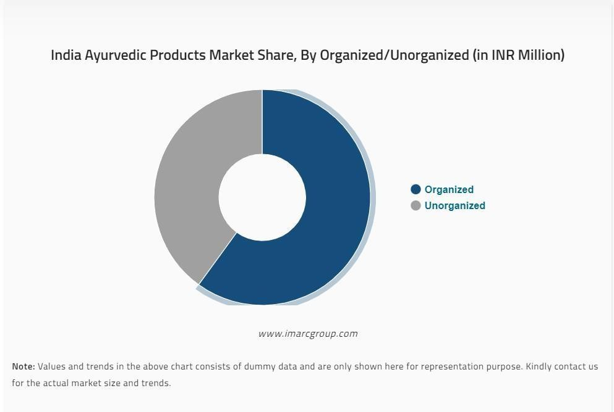

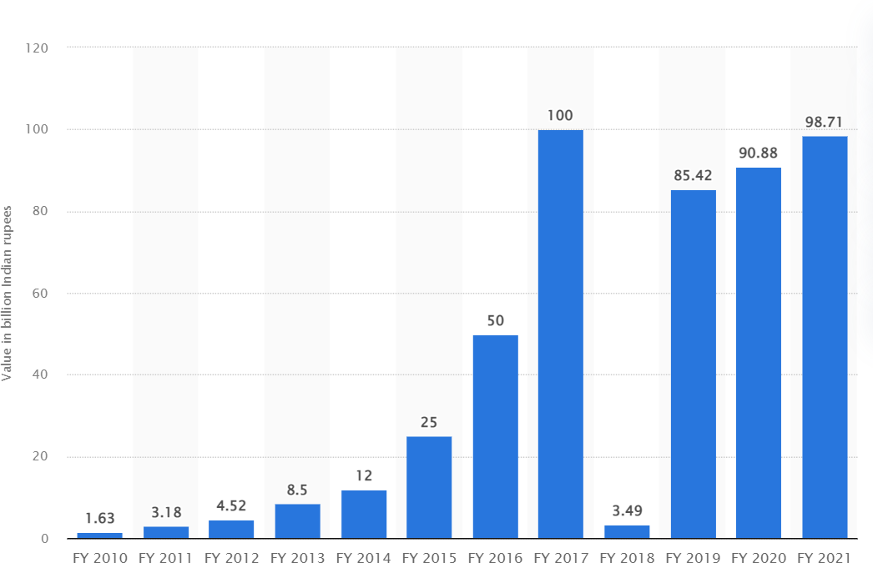
MAJOR COMPANIES AND THEIR PERFORMANCE
Revenue of Patanjali Ayurveda across India from financial year 2010 to 2021(in billion Indian rupees)

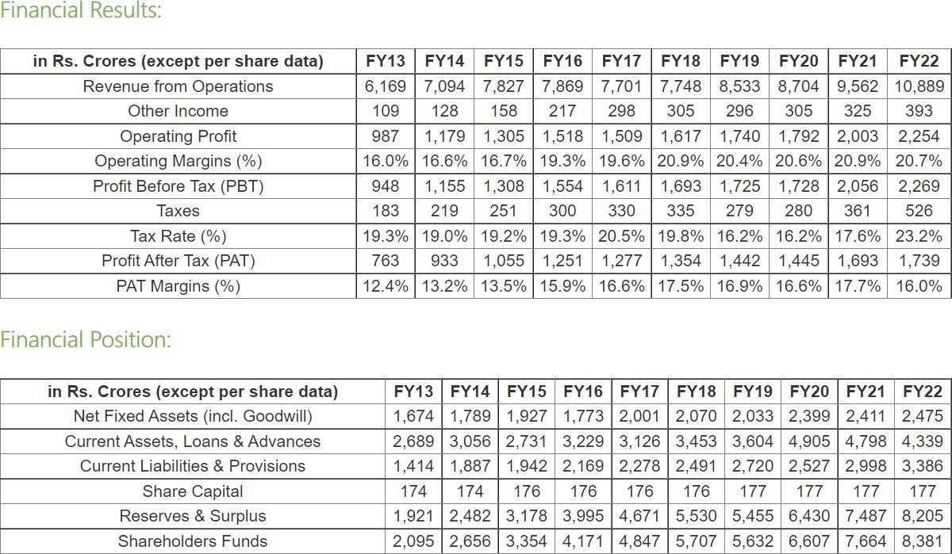
DABUR :
ITS 10 YEARS HIGHLIGHTS

CHAPTER NO. 3

COMPANY PROFILE

COMPANY PROFILEHISTORY

Baidyanath Group is an Indian pharmaceutical firm specializing in Ayurvedic medicines. Shree Baidyanath Ayurved Bhawan (Pvt) Limitedwas founded in 1917 by two brothers, Vaidya Pandit Ram Narayan Sharma and his brother Pandit Ram Dayal Joshi with a vision of providing effective and readily available medicines to the population of India. Pandit Ramnarayan Sharma, an illustrious practitioner of Ayurveda, made asmall beginning by starting the manufacture of Ayurvedic medicines at Baidyanath Dham in Bihar in the year 1917 and then pioneered a large scaleproduction of Ayurvedic formulations with his brother . Under the flagship of Shree Baidyanath Ayurved Bhawan, this expansiondid not prove sufficient, and a new work came up at Baddi (Solan),Himachal Pradesh in the year 1995. Now, new plants exist at Barotiwala (Himachal Pradesh), Kashipur (Uttarakhand), and Seoni (Madhya Pradesh). The current Managing Director Of BaidyanathGroup is Shri. Ram K Sharma at Kolkata and Shri. Suresh Kumar Sharma atNagpur.
In 2017, the group completed 100 years and decided to foray into the FMCGmarket with the introduction of new products like Amla, Aloe vera, Karela Jamun, Giloy varieties, and Herbal Tea. The age-old ayurvedic brand not only sells its products through offline channels, but also through various online platforms. During COVID- 19 times, Baidyanath’s participated in one of the biggest online events,Amazon’s Prime Day, to ensure that some of their best immunomodulators seamlessly reach their customers’ doorsteps with the help of Amazon.Also, the demand for this brand’s ayurvedic products increased during the COVID phase, especially for immunity boosters such asGiloy, Giloy Batti, and Chyavanprash. Baidyanath Group awarded 1.5 lakh INR for the best research paper or bookon Ayurveda every year during 2016-19. The group also facilitated the practitioners of Ayurveda as a part of Dhanwantari Jayanti

VISION

At Baidyanath, we believe in offering you quality of life. Simply because, we know that to cope with the frenzied pace of today’s life, you always strive to keep fit and healthy. To meet the needs of healthy modern living, you need supports that are natural and safe.

We found these answers in the ancient wisdom of AYURVEDA. And since1917 we used our vast experience and expertise, delved deep into the resources of AYURVEDA, blended it seamlessly with modern research and manufacturing technology. The result is the creation of a whole range of Ayurvedic lifestyle solution products that help you lead a better life, naturally. Shree Baidyanath Ayurved Bhawan was founded in 1917 by late Pt. Ram Dayal Joshi with a vision of providing effective and readily available medicines to the population of India. The legacy is forever etched in the company in the form of its strive to achieve excellence and set new standards. His only mission was to cure people from diseases. The oldest and pioneer of Ayurvedic Medicine, Baidyanath Ayurveda has also been evolving with changes of times. of today’s patients and focusing on wide spread availability of the qualitymedicines in affordable prices in nook and corner of the country. In a interview director of baidyanath ayurved

Company shared his vision andmilestone of his company:-
My journey started with a very profound statement I heard when I was 30:80% of family businesses do not survive the third generation, globally. It’sshocking when you hear this the first time. To top it all, I was the third generation in my family business and so there was a lot of burden on my shoulders. At Baidyanath, our family is steeped in the tradition and knowledge of Ayurveda. We were exposed to these ancient scriptures and knowledge froma very young age. I drew an analogy to the trinity of Hinduism; Brahma – the creator, Vishnu – the preserver and Mahesh – the destroyer. My young mind said, hey am I Mahesh? Have I been born to destroy what my grand- father created and my father preserved? And, mind you, the business has to grow to preserve it.But then my logical side of the brain said, 20% businesses have survived. They must have done something right or something right must have happened to them. The inquisitiveness to know about this made me move onin my journey. The lessons I learnt from my own business, the observation from other similar business around me and then ultimately studying 250-oddfamily businesses, some of them which unfortunately did not stay alive while some did and some thrived. The knowledge gathered has been concised in this book that I wrote – how to thrive in a family business.
It is important to understand what exactly is meant by a family business. So,if two brothers start a business, it is a mere partnership. It does not qualify tobe a family business. Only when the young generation, the next generation, joins in this partnership that the institution of the family business takes shape. So, if the foundation of a family business is based on the next generation joining in, it becomes important to understand and manage thisgenerational dimension. Going back to the ancient scriptures, they talk about four ashrams – Brahmacharya, Grishastashram, Vanaprasthashram and sanyas. Putting this knowledge in the context of a family business, I devised a theory of four Tsin the life cycle of a family business. They are – training, transaction, transition and turning. Training, we all start our life with it. We are born and we want to acquire some soft skills, some hard skills and there is a normal urge to get into the transaction mode. Nobody tells you this; you are just keen to do well and start fresh, get into transaction mode. So, T1 and T2 just naturally happen. Those of us I see here are in T3. They will see there is a natural progressionthat takes you to T4, sanyas. The core disconnect actually appears between T2 and T3. Most of us do not see the dawn of vanaprastha and those of us who do are in denial mode. I have heard statements that: the business needs me or what will I do? Or I have milestones to achieve, I have to cross an X turnover or I have to take my brand global. Well, these are all excuses because these are all about I andMe. They are not about the family business or the family. So, it is important for us to understand that there comes a time of vanaprastha which has to be taken seriously. In this study, I realized that vanaprastha is the most important part in the four stages and the most critical and the least understood. So, I would like to deep dive into it and discuss two points on Vanaprastha. Firstly, it is a fallacy that it is a one-day affair. One should not take it as a coronation of a king. It is not a kingdom; it is a family business. So, first wemust throw this out that it is a one-day affair. The way we spend X number of years in Brahmacharya, in training, and Y number years in transaction India is an agrarian economy and in agriculture, strength and muscle are important. The eldest one grows up and becomes the responsible one. Plus, we have been ruled by the kings and the queens over the century and they have a law that the eldest male heir will inherit the throne. Then we have theHUF where the eldest male will be the karta of the family. This is years and centuries of conditioning of our mind. So, while we moved from agricultureto business, our minds did not. It is important to understand this point and families have to stop committing this sin because while agriculture is about strength, business is about a sharp mind. While HUF is about continuity, business is about competency. And monarchy is about a figure head while business is about leadership and vision.
Relinquishing ownership is the next eternal sin that appears in sanyas. Believe me it is mandatory to relinquish ownership in sanyas. If you do not do that, you will not plan financial security for self and for independence. A lot of us hold on, that ownership is security. So, the case is clear, you have tohave to do that, or you who are the asset of the company becomes a liability for the company because as long as you are there you try to see financial security. So, you must do this act to gain financial security. The Roman Catholic theology talks about seven basic sins and because of that all sins happen. They are known as the Catholic Cardinal Sins. In my book also sins 2 to 8 in Brahmacharya are the cardinal sins of a family business. Because ofthat, the balance of the 21 sins happen.

Sin 29 is close to my heart which is not having an exit policy. In businesses, and especially in India, we don’t have an exit policy for members. Here I amnot talking about selling the business and monetizing it, it is having an exit policy for a single member. In fact, it is a taboo. I have heard authoritative statements like you are born here and you will die here. What appeared in my study is that it is taken as a value judgement on a family business. There is always a ring of suspicion, why is he asking for exit? Or a sense of betrayal. Believe me you cannot trap a soul in a family business. You cannottrap. It is advised not to do that and have a robust fair exit policy. You wouldalso see that it gives you a leaner ownership to move on. Mode, there is a Z number of years you need to spend in vanaprastha which is a transition mode and in the balance number of years that goes to sanyas. It is important to understand that. The second part which is also important isthat you have to learn two arts – the art of giving and the art of self- exploration, self- fulfillment. We Indians, from childhood, we are taught about charity and donation, we are taught to give away our toys, clothes, we donate to the orphanage, shelterhomes and then our festivals are always about donating blankets etc. We are always giving away but vanaprastha says learn the art of giving back to society. There is a big difference between giving back and giving away. Giving awayis an act of generosity and giving back is an act of gratitude; one has to learnthat to be able to live vanaprastha better. The second part is self-exploration.You have given enough of your time and money and everything to the business and the family. It is time to give that back to yourself too. You haveto explore what you are, you have to get back to yourself. We may have some talent which may want to pursue. We may have a cause which we maywant to back, we may have a passion, we all have some will to do something. This is the time! And believe me, I am going through my vanaprastha, if you do this and learn these two arts, your transition mode becomes extremely enjoyable and fulfilling. You actually learn how to pass on business to the next generation because you get into that role. Otherwise, you keep clinging on to it. So, transition is the core point which I discuss in this book. The other part with those who will end up going through this book of mine, you will see that I mentioned in the four stages of life, we commit 30 actionswhich are the sins of a family business. So, I’ll not go deep into it but swim around it. Sins 1 and 30 are the eternal sins – it is the elder son syndrome and relinquishing ownership
I will end this session with a small story from Mahabharat. By a quirk of fate, Abhimanyu got to know how to get into a Chakravyuh, unfortunately he did not know how to get out – the exit – and he died fighting that. When the news reached his father, he along with his uncles went on a rampage anddestroyed the Kaurava Dynasty. I don’t want this to happen to any family business. So, you must never trap a person and you should have an exit policy. I rest my case!

Baidyanath, on the other hand, has about 700,000 retail stores with over 5500 franchisees. Baidyanath mainly focuses on the production of medicines. They provide their customers with a range of more than 300 medicines. Baidyanath Group has worked tirelessly for over a century for developing good quality medicines for its customers. Although The Baidyanath Group has established a significant amount of retail stores more than Patanjali Ayurveda, it still lacks very much behind them in terms of the number of products manufactured and the variety of products manufactured. This is because Baidyanath only focuses on producing medicinal products, while Patanjali produces a wide range of products along with medicinal and health care products such as Natural Food Products, Herbal Home Care, and many more that are already discussed. Therefore, it can be seen that ‘Patanjali Ayurveda’ wins here by a very small amount of margin . Shree Baidyanath Ayurved Bhawan Pvt Ltd is an unlisted private company incorporated on 22 May, 1947. It is classified as a private limited company and is located in Kolkata, West Bengal. It's authorized share capital is INR 2.00 cr and the total paid-up capital is INR
30.00 lac.

MILESTONE
Shree Baidyanath Ayurved Bhawan's operating revenues range is Over INR 500 cr for the financial year ending on 31 March, 2021. It's EBITDA has increased by 84.09 % over the previous year. At the same time, it's booknetworth has increased by 12.61 %.

PRODUCT PROFILE

What Is Ayurvedic Medicine?
The ancient Indian medical system, also known as Ayurveda, is based onancient writings that rely on a “natural” and holistic approach to physical
and mental health. Ayurvedic medicine is one of the world’s oldest medicalsystems and remains one of India’s traditional health care systems. Ayurvedic treatment combines products (mainly derived from plants, butmay also include animal, metal, and mineral), diet, exercise, and lifestyle.

What the Science Says About the Effectiveness of Ayurvedic Medicine

Few well-designed clinical trials and systematic research reviews suggest that Ayurvedic approaches are effective. Results from a 2013 clinical trial compared two Ayurvedic formulations of plant extracts against the natural
product glucosamine sulfate and the drug celecoxib in 440 people with knee osteoarthritis. All four products provided similar reductionsin pain and improvements in function. A preliminary and small NCCIH-funded 2011 pilot study with 43 people found that conventional and Ayurvedic treatments for rheumatoid arthritis were similarly effective. The conventional drugtested was methotrexate and the Ayurvedic treatment included 40 herbal compounds. Outcomes from a small short-term clinical trial with 89 men and women suggested that a formulation of five Ayurvedic herbs may helppeople with type 2 diabetes. However, other researchers said inadequate study designs haven’t allowed researchers to develop firmconclusions about Ayurveda for diabetes. Turmeric, an herb often used in Ayurvedic preparations, may help with ulcerative colitis, but the two studies reporting this were small—one, published in 2005, included 10 people while the other, published in 2006, had 89.

What the Science Says About the Safety of Ayurvedic Medicine

Some Ayurvedic preparations include metals, minerals, or gems. The U.S. Food and Drug Administration warns that the presence of metalsin some Ayurvedic products makes them potentially harmful.A 2015 published survey of people who use Ayurvedic preparations showed that 40 percent had elevated blood levels of lead and some had elevated blood levels of mercury. About one in four of the supplements tested had high levels of lead and almost half of them had high levels of mercury.A 2015 case report published in the Center for DiseaseControl’s Morbidity and Mortality Weekly Report linked elevatedblood lead levels in a 64-year-old woman with Ayurvedic preparations purchased on the Internet. Although rare, Ayurvedic products may cause arsenic poisoning.

NCCIH-Funded ResearchNCCIH is funding research that:
Builds on earlier investigations in breast cancer survivors that found apositive effect of integrated Ayurvedic medicine on improved qualityof life; new research will evaluate ways to make this intervention easier to incorporate into peoples’ lives. The proposed Ayurvedicintervention includes diet, lifestyle, yoga, and pressure point treatment.Studies the mechanism by which an extract from Butea monosperma (BME) flowers may protect against joint destruction from osteoarthritis (BME is widely used in Ayurveda for arthritis andother inflammatory diseases in India).

Ayurvedic Health Benefits
Balances all three doshas Improves digestion and energy levels Cleanses the liver and kidneys Boost immunity, energy and endurance Greater mental focus and positive feeling Reduce stress levels and gain better quality sleep Gain a positive shift in your relationship to plant foods Increases motivation to exercise on a regular basis
Hydration: Plant juices consist mostly of water and help to hydrate and nourish the body. Staying hydrated is vital for your body, and helps maintain blood pressure, body temperature, brain function, nutrient absorption, elimination of waste, and promotes

healthy kidneys.
Low in Sugar: Plant juices are low in sugar. A single cup (240 ml) has only5 grams of naturally occurring sugar.
Anti-inflammatory: Plant juice is high in plant nutrients which help reduceinflammation throughout the body. Plant juice contains luteolin and pyrroloquinoline quinone, two plant compounds known to reduce inflammation in the digestive tract.
Antioxidant: Plant juice is high in antioxidants which help reduce rates of chronic ailments, including heart disease, diabetes, obesity and cancer.

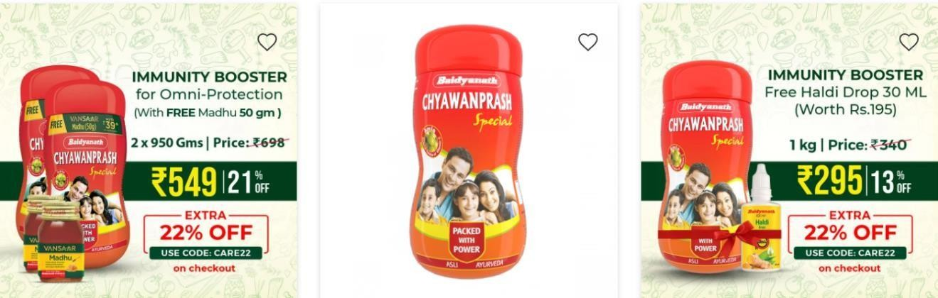

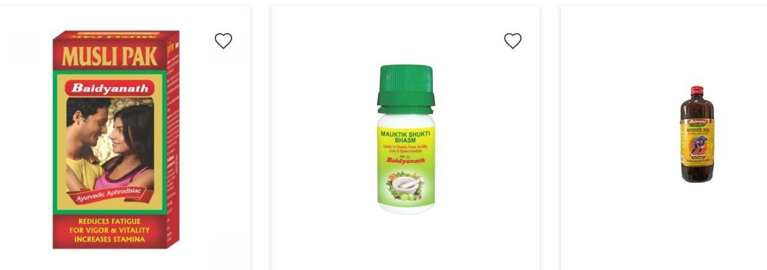

CHAPTER 4

OBJECTIVES

OBJECTIVES

- To understand customer satisfaction and their need.
- The second objective of my study was to collect the market datafrom the market itself.
- To identify the buying behavior of the target market.
- To analyze the market opportunity.

CHAPTER 5

RESEARCH METHODOLOGY

RESEARCH METHODOLOGY

Research:
Once the problem has been carefully defined, the researcher needs to establish the plan that will outline the investigation to be carried out. Theresearch design indicates the steps that have been taken and in what sequence they occurred. It is a systematic and purposive Investigation of facts with an objective of understanding the people’s interest in a specific role. The methodology thatwill be applied by the study has been chosen in order to acquire informationand deduce conclusions about the -major interns holding side. The main purposes of this study is to see in which internship people are more interested in this work place.

PRIMARY DATA
Primary data is a type of data that is collected by researchers directly from main sources through interviews, surveys, experiments, etc. Primary data areusually collected from the source—where the data originally originates fromand are regarded as the best kind of data in research. The sources of primary data are usually chosen and tailored specifically to meet the demands or requirements of particular research. Also, before choosing a data collection source, things like the aim of the research and target population need to be identified.
Primary data was collected through structure questionnaire

SAMPLING
Sampling means selecting the group that you will actually collect data from in your research. For example, if you are researching the opinions ofstudents in your university, you could survey a sample of 100 students. In statistics, sampling allows you to test a hypothesis about the characteristics of a population. It is also a time-convenient and a cost- effective method and hence forms thebasis of any research design. Sampling techniques can be used in a researchsurvey software for optimum derivation. For example, if a drug manufacturer would like to research the adverse sideeffects of a drug on the country’s population, it is almost impossible to conduct a research study that involves everyone. In this case, the researcher decides a sample of people from each demographic and then researches them, giving him/her indicative feedback on the drug’s behavior.

POPULATION
A population is the entire group that you want to draw conclusions about. A sample is the specific group that you will collect data from. The size of the sample is always less than the total size of thepopulation. In our research size of our population is 1000.

SAMPLE SIZE
The sample size is defined as the number of observations used for determining the estimations of a given population. The size of the sample has been drawn from the population. Sampling is the process of selection of a subset of individuals from the population to estimate the characteristics of the whole population. The number of entities in asubset of a population is selected for analysis. For this research sample size is 100.

SCOPE OF THE STUDY
The scope of the study is always considered and agreed upon in the early stages of the project, before any data collection or experimental work has started. This is important because it focuses the work of the proposed studydown to what is practically achievable within a given timeframe. A well-defined research or study scope enables a researcher to give clarity tothe study outcomes that are to be investigated. It makes clear why specific data points have been collected whilst others have been excluded. Without this, it is difficult to define an end point for a research project sinceno limits have been defined on the work that could take place.

LIMITATIONS OF THE STUDY
The following are the limitations of the study
One of the limitations of the study can be time duration 60 dayswas very less time to complete the project.
The responses received may be biased.

CHAPTER 6
THEORITICAL BACKGROUND OF THE STUDY

  - THEORITICAL BACKGROUND OF THE STUDY
INTRODUCTION

Research is the prime need of contemporary Ayurveda, but modern researchon Ayurveda has not been very rewarding for Ayurveda itself. Much of it uses Ayurveda to extend modern bioscience. In contrast, Ayurveda needs research designed to test and validate its fundamental concepts as well as its treatments. In this context, if Ayurveda is to be truly explored and validated in all its aspects, scientific inputs should conform to Ayurveda's principles and philosophy. While its evidence base, established since antiquity, may need further verification, research should now focus on the Science of Ayurveda, rather than merely looking for new drugs based on Ayurveda herbals; in-depth research is needed on Ayurveda. Such research will requireteamwork between scientists and vaidyas based on truth and trust. Ayurveda research methodology requires the ‘whole system testing approach’, global participation with protocols evolved through intense interface with modern science, regulatory reforms to eliminate barriers, and to be investigated ‘as itis’, using approaches adapted from its own basic principles. edic researches undertaken during the last 50 years have not been very rewarding, except forthe extremely useful exercise of literary research, which has at least made a few of the classical Ayurvedic texts accessible to contemporary readers and researchers. Similarly, a number of literary reviews published in recentyears have helped create a conceptual interface between Ayurveda and modern science. However real laboratory-based new research is still awaited. Such a scientific stalemate warrants developing newer strategies forresearch in Ayurveda with appropriate methodology in keeping with the fundamental principles of Ayurveda-as-it-is, without distorting it to suit the application of modern research technology. In any research, the goal of research should not be compromised to suit the convenience of research methods. But unfortunately in Ayurvedic research, there has always been a reverse compromise, and in my perception this attitude is the main reason for failures in this otherwise potentially most fruitful field of contemporary medical research. The so-called scientific research of several decades has helped neither Ayurveda nor modern medicine to any significant extent except in creating awareness. The present challenges are globalization of Ayurveda and industrialization of the Ayurvedic drug sector that needs standardization and quality assurance of in-use drugs, besides developing new drugs and formulations for more recent indications. That classical Ayurvedic formulations seem to be losing ground is evident from the drasticcuts in production and sale of classical drugs by most Ayurvedic drug companies. On the other hand, there is a strong need to explain fundamentalprinciples of Ayurveda in a modern context. Further, we must also address the growing demand for an “evidence-base.” Hence research is the prime need of contemporary Ayurveda. On the other hand, despite modern research in Ayurveda not having been very rewarding till now, it cannot be overemphasized that modern scientific inputs are unavoidable in this kind of research, the only rider being that, if Ayurveda is to be truly explored, such scientific inputs should conform to the principles and philosophy of Ayurveda.

THE EARLY ATTEMPTS IN INDIA

Till now, the best research and development in Ayurveda has been the contribution of commentators on Samhitas as well as scholarly works and translations of Ayurvedic classics in modern languages, such as the works ofYadavji Trikamji Acharya, Acharya Priya Vrata Sharma, GD Singhal, MS Valiathan, and several others. The credit for early attempts at modern drug- oriented research goes to individuals like RN Chopra, KN Udupa, and a few others besides, and to the establishment of Central Drug Research Institute, Regional Research Laboratory, Jorhat (RRLJ), Central Council for Researchin Ayurveda and Sidha, and the Department of Ayurveda, Yoga, Unani, Siddha and Homeopathy (AYUSH), Govt of India. The identification of reserpine from sarpagandha as a therapeutic agent emerged as the big success story of the early 20th century, attracting large numbers of researchers; but within only a few years, this new phytochemical was subsequently withdrawn from the market as a drug because depression was asevere side effect, even though sarpagandha as a whole natural drug is free of the effect and continues to be in use even today. This event proved to be a turning point in the field, shifting the research paradigm from active chemical constituents toward trials of the whole drug More recently, the golden triangle project has been launched along the lines of the composite drug research scheme, which ended inconclusively during the late sixties, and the ongoing project on “Science Initiatives in Ayurveda”and the policy exercise for proposed Council for International Cooperation in ISM are still to take off.

DIMENSIONS OF CONTEMPORARY AYURVEDIC RESEARCH

The overall spectrum of contemporary research activities in Ayurveda includes literary and conceptual study, clinical and therapeutic research, anddrug development research including drug standardization and new drug development. I have always been of the opinion that Ayurveda requires a two-pronged research enterprise:Research in the science of Ayurveda, Research on therapeutics of Ayurveda. Earlier attempts were overwhelmed by drug research without any real breakthrough outputs. Now the paradigm seems to be shifting toward research on Science of Ayurveda as evidenced by Valiathan's project on Science Initiatives in Ayurveda. My experience of collaborative research onAyurveda during the last several decades prompts me to think that Ayurvedic research needs more collaboration with basic scientists than with professional medical doctors, because Ayurveda is more easily explainable in terms of basic sciences like physics, chemistry, and basic life sciences than in the language of conventional biology and medicine. Use to be registered, because their safety and efficacy can be deduced from their long standing use. The long tradition of the medicinal product permits requirements for clinical trials to be waived, insofar as the efficacy of the medicinal product is plausible on the basis of long-term use and experience. Preclinical tests do not seem necessary either, where the medicinal product on the basis of the information on its traditional use proves not to be harmfulin specified conditions of use.”
This seems to be a laudably lenient stand, with which I personally agree, because Ayurveda in India has a superior status, many of its products and formulations having been in use for several hundred years, not merely decades. But I do not know whether this stand will be acceptable to the scientific community at large. However, one thing is sure: traditional medicine research does not require the same scientific rigor as conventionalmodern drug development programs.
EMERGING ISSUES AND THE SECTORIAL CONCERNS
In spite of many attempts at research in Ayurvedic therapeutics, no noteworthy outcome has emerged. Equally, no initiatives have so far been taken to study the core science of Ayurveda. Potentially valuable treasures in Ayurveda's unique concepts and theories remain unexplored. Thus, research in Ayurveda during the last several decadeshas not produced any major breakthrough. Most so-called scientific studies have yielded negative results, warranting a serious reconsideration of the very approach of research and on-going research methodology. Many serious researchers now consider current research approaches to be inappropriate, and that a major paradigm shift to in- depth Ayurveda- oriented research on Ayurveda is needed. Ongoing research is proceeding in such a way that it is of more value tomodern medicine than Ayurveda. It does not strengthen Ayurveda and Ayurvedic practice. Ayurvedic research outcomes have not yet trickleddown to professional use, nor do they benefit Ayurveda students or practitioners. Inadequacies in currently available regulatory laws are also proving a barrier, because many drugs and formulations developed through new research have no drug status particularly for Ayurvedic practitioners. For example, sarpagandha has a legal drug status for Ayurvedic doctors, but reserpine isolated from sarpagandha may have adrug status for allopaths, but not for Ayurvedic practitioners. Hence such research is of no value to them. The recent paradigm shift demands research initiatives in the science of Ayurveda including exploration of more recent approaches and methodologies of therapeutic research, in order to enrich Ayurveda as itis, and to benefit Ayurvedic practitioners.

NEWER STRATEGIES

I am inclined to suggest that ongoing research by experts of conventional medical sciences should be continued to the benefit of their own system, but that a new approach should be adopted to research Ayurveda as a system of science and therapy, specifically within the framework of principles and philosophy of Ayurveda. Bothapproaches need collaboration between experts of Ayurveda, basic sciences, and medicine. However, there is a need of true teamwork between these three, which will only be possible if there is trust between team members. Such trust will only prevail if all members ofthe team practice truth. Thus truth-trust-teamwork is the vital chain in interdisciplinary research, which has been lacking, and has been the main cause of failure of otherwise well-conceived projects like Composite Drug Research Scheme (CDRS), Golden triangle project, and Science Initiatives in Ayurveda.

LIMITATIONS OF THE CONVENTIONAL APPROACH

Western medical science is fast developing, while Ayurveda is already a fully developed science of its own kind. The two have very different approaches. Conventional medicine and its research methodologies are largely based on classical Newtonian physics and related biological considerations. In contrast, Ayurvedic life sciences are based on a holistic logic now emerging in quantum science. This is why Ayurvedadoes not follow the organ-oriented anatomy and physiology, and adoptsits own function-oriented approach through its alternative theories of Panchamahabhut, Tridosha, Dhatu, Agni, Ama, Ojas, and Srotas, which cannot be fully explained in terms of conventional anatomy and physiology. Hence Ayurveda research methodology has to develop itsown approach. “QUANTUM LOGIC”

Over the past 50 years, the fundamental sciences have been gradually modifying many notions in physics and bioscience, gradually shifting to quantum logic and nanoscience. In the same sequence, modern science has developed unified field theories in quantum physics, similarto the ancient Indian concept of a unified field of consciousness, in which individual human consciousness (Atman) and universal cosmic consciousness (Brahman) are realized to form a continuum. However, such a unified field of consciousness seems to involve a kind of nonphysical energy, in contrast to the unified field concept in conventional science, which merely refers to physical energy.
The entire basic bioscience of Ayurveda is based on this philosophy,and is in conflict with the conventional reductionist approach that identifies material structures and their functions, that is, structure– function relationships. In this context, it is pertinent to quote the Cambridge Nobel laureate, physicist BD Josephson, who states “The basic premise of western science is that of an objective reality that can be reduced to a measurable uniform formula. Eastern philosophy on theother hand places emphasis on conscious experiences and subjective reality. Quantum theory poses problems for the idea of objective reality. There is difficulty in reconciling the two approaches because the reality is too complex to be reduced to an objectively identifiable formula. Subjectivity has to play an important role.”

CHAPTER 7

DATA INTERPRETATION AND DATA ANALYSIS

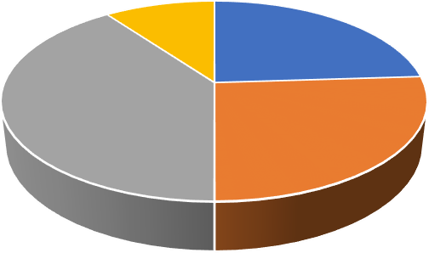
Q1. What is your age?
10
24
40
26
18-25 26-30 30-40 40+

Table no. 1 : Age

Sr. No | AGE | NO OF  RESPONSES | PERCENTAG  E
1 | 18-25 | 24 | 24
2 | 26-30 | 26 | 26
3 | 30-40 | 40 | 40
4 | 40+ | 10 | 10
 | Total |  | 100

( Source : survey )

Chart No : 1 age

From our survey we know that Out of 100 responses :40 of shopkeepersare of 30-40 years.26 of shopkeepers are of 26-30 years.24 of shopkeepers are of 18-25 years.10 of shopkeepers are more than 40 years.

Q2 . what is your gender?

Table no 2 : Gender

SR. | GENDER | NO OF  RESPONSES | PERCENTAGE
1 | MALE | 78 | 78
2 | FEMALE | 22 | 22
 | TOTAL | 100 | 100
(Source: Survey)







Gender

22%

78%
Male
Female

Chart no.2 : Gender

INPRETATION:- From our research we observes that Out of 100 responses78 are men And, 22 are female shopkeepers.

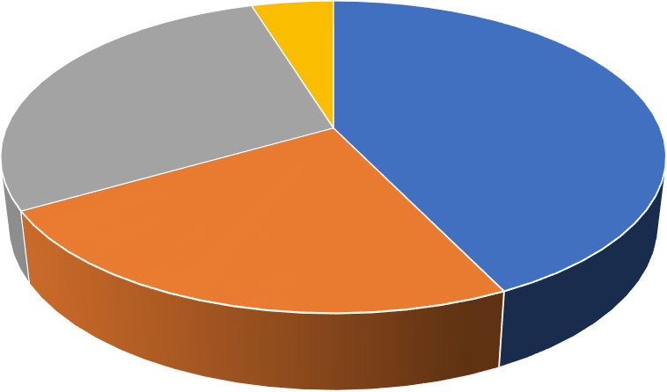
Q3. Which brand of juices sells the most in percentage?
Brand
30
45
25

TABLE NO. 3 : Brand
Sr. No. | Brand | No. of responses | Percentage
1 | Patanjali | 45 | 45
2 | Dabur | 25 | 25
3 | Baidyanath | 30 | 30
4 | Himalaya | 5 | 5
 | Total | 100 | 100
(Source: Survey)

PATANJALI DABUR BAIDYANATH
CHART NO. 3
INTERPRETATION: From our survey we know that Out of 100 responses we can see that 45 % of the total sales are of Patanjali,30% of the total sales are of baidyanath,25% of total sales are of dabur,5% of total sales are ofHimalaya.

Q4.PERCENTAGE WISE SALES OF JUICES ?

TABLE NO. 4
Sr. No. | Juice | No of responses | Percentage
1 | Aloevera | 44 | 44
2 | Amla juice | 14 | 14
3 | Karelajuice | 18 | 18
4 | Giloy juice | 24 | 24
 | Total | 100 | 100
(Source: Survey)

44

24

18
14

 |  | ALOEVERA JUICE | AMLA JUICE  JUICES | KARELA JUICE | GILOY JUICE
 | JUICES | 44 | 14 | 18 | 24
CHART NO. 4

INTERPRETATION

Out of 100 % of sales Maximum selling juice is aloevera juice with 44%After that, giloy juice was the second most selling juice At 3rd position there is karela juice And at last with least selling percentage is amla juice i.e, 14%.

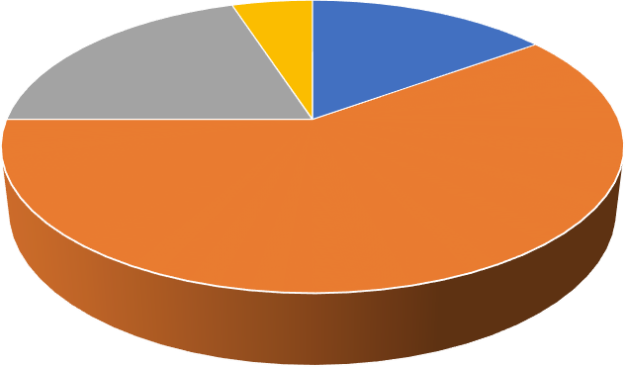
Q5.HOW FREQUENTLY CUSTOMERS PURCHASES ?
5%
15%
20%
60%
EVERY 15 DAYS
EVERY MONTH
ONCE IN A TWOMONTHS
ONCE IN A WHILE

TABLE NO. 5
Sr | Frequency | No. of responses | Percentage
1 | Every 15days | 15 | 15
2 | Every month | 60 | 60
3 | Once intwo months | 20 | 20
4 | Once in awhile | 5 | 5
TOTAL |  | 100 | 100
SOURCE : SURVEY

CHART NO. 5

INTREPRETATION:
Out of 100 responses 60%uses every month,20% uses once in twomonths,15% uses every 15 days,5% uses once in a while.


Q6. What do you think about the price of the product ?

TABLE NO. 6

Sr. | Price | No of responses | Percentage
1 | Very high | 60 | 60
2 | High | 5 | 5
3 | Average | 10 | 10
4 | Less | 18 | 18
5 | Very Less | 07 | 07
 | TOTAL | 100 | 100
SOURCE : SURVEY

60

5
10
18
7
VERY HIGH HIGH AVERAGE LESS VERY LESS

CHART NO. 6

INTERPRETATION
According to my survey Out of 100 responses 67 believes the price is normal.18 people cannot equate the price10 people consider it cheap5 people consider it expensive.

Q7.do you prefer to sell the product of baidyanath over other brand ?

Table no. 7

Sr | Preference | No of responses | Percentage
1 | Yes | 80 | 80
2 | No | 20 | 20
 | Total | 100 | 100
SOURCE : SURVEY
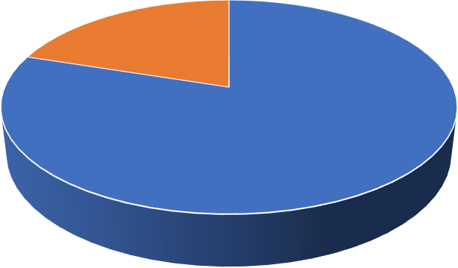

20

80

YES NO
CHART NO. 7

INTERPRETATION
Out of 100 responses 80 shopkeepers prefer selling baidyanath over any other brand 20 shopkeepers do not prefer it.

Q8. DO BAIDYANATH OFFER MORE INCENTIVES/PROFIT THAN OTHER BRANDS?

TABLE NO.8

SR | INCENTIVES | NO OF RESPONSES | PERCENTAGE
1 | YES | 44 | 44
2 | NO | 56 | 56
 | TOTAL | 100 | 100
SOURCE : SURVEY
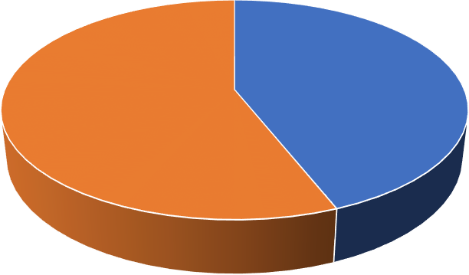

44

56

YES NO
CHART NO. 8

INTERPRETATION
Out of 100 responses 56 shopkeepers agreed about more incentive44shopkeepers denied about getting more incentive.

Q9. Do baidyanath company fulfill the demand of market?

TABLE NO. 9

Sr | Demand | No of response | Percentage
1 | Yes | 52 | 52
2 | No | 36 | 36
3 | Varies sometime | 12 | 12
 | TOTAL | 100 | 100
SOURCE : SURVEY


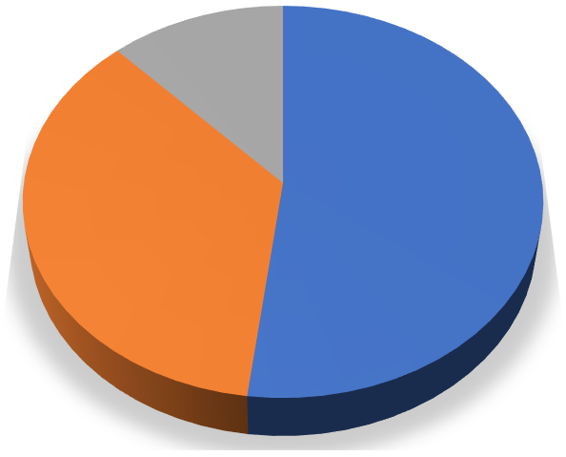







12%

52%
36%
Yes No
Varies sometime
CHART NO. 9

INTERPRETATION

Out of 100 responses52 shopkeepers agree that they maintain the supplychain throughout the year36 shopkeepers do not agree with the statement.12 shopkeepers think that it varies sometime .











Q10. Are you facing any challenges while selling baidyanath juices ?
16%
7%
77%

TABLE NO.10
Sr | Challenges | No of responses | Percentage
1 | YES | 7 | 7
2 | NO | 77 | 77
3 | SOMETIMES | 16 | 16
 | TOTAL | 100 | 100
SOURCE : SURVEY

YES NO
SOMETIMES

CHART NO. 10

INTERPRETATION:
OUT OF 100 RESPONSES 77 shopkeepers don’t faces any challenges while selling it.16 shopkeepers faced challenges sometime.7shopkeeperfaces challenges while selling it.

Q11. Do Baidyanath Distributors Visit Every Week ?

TABLE NO. 11
SR | VISIT | NO OF RESPONSES | PERCENTAGE
1 | YES | 90 | 90
2 | NO | 0 | 0
3 | PARTIALLY | 10 | 10
 | TOTAL | 100 | 100
SOURCE : SURVEY

 | 90 | 0 | 10
YES NO P A R T I A L L Y
CHART NO. 11

INTERPRETATION:
Out of 100 responses90 shopkeepers says yesAnd 10 shopkeepers saysno.


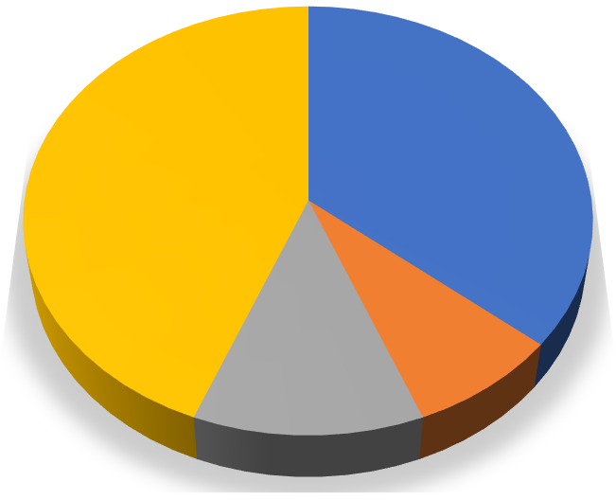








Q12.What Do You Like Most About Our Product And Services?
36%
44%
12%
8%

TABLE NO. 12

Sr | Likes | No Of Responses | Percentage
1 | Quality | 36 | 36
2 | Packaging | 8 | 8
3 | Taste | 12 | 12
4 | Health benefits | 44 | 44
 | TOTAL | 100 | 100
CHART NO. 12

Quality Packaging Taste
Health benefits

INTERPRETATION:
Out of 100 responses44 shopkeepers agree to its health benefits of the product36 shopkeepers agree to quality of the product.12 shopkeepers prefer it for its taste8 shopkeepers consider it for its packaging.










Q13. Is there any change needed in the product ?
17%
3%
80%
Table No. 13
Sr. | Opinion | No. Of responses | Percentage
1 | Yes | 3 | 3
2 | No | 80 | 80
3 | Sometimes | 17 | 17
 | Total | 100 | 100
(SOURCE: survey)

Yes
No Sometimes

INTERPRETATION:
Out of 100 responses80 shopkeepers don’t think there is a need of any changes in the product.17 shopkeepers says sometimes there is a changeneeded3 shopkeepers says it80 should change its product.


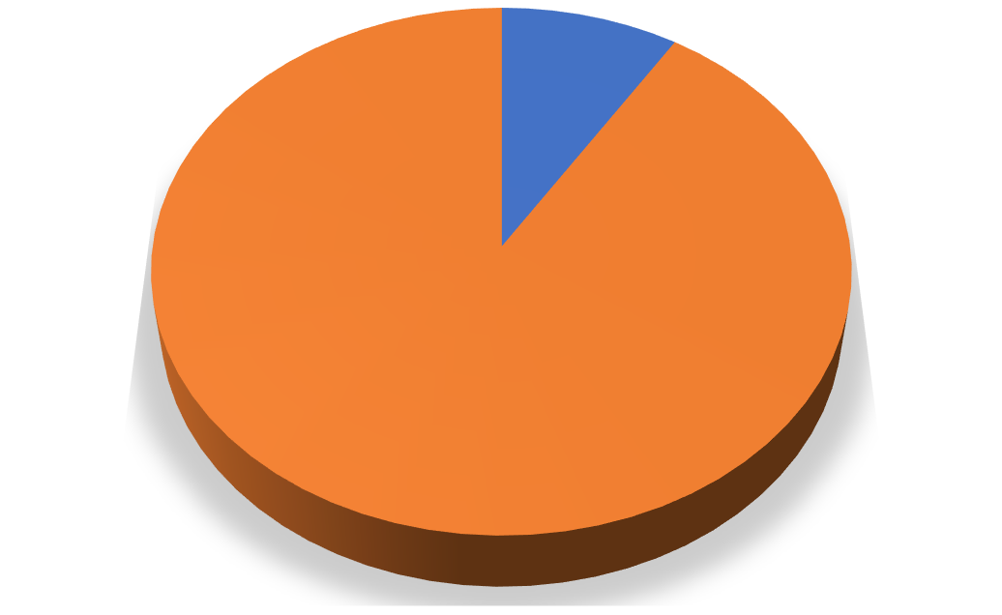




Q14. Are you satisfied with the baidyanath juices?
Table. No. 14

SR | SATISFACTION | NO OF RESPONSES | PERCENTAGE
1 | YES | 9 | 9
2 | NO | 91 | 91
 | TOTAL | 100 | 100
(source: survey)

9, 9%

YES
NO
91, 91%

Chart no.14

Interpretation:
Out of 100 responses91 shopkeepers are satisfied with baidyanath juice And, 9 shopkeepers are unsatisfied.

CHAPTER 8 FINDINGS

- From our survey we know that out of 100 responses :40 of shopkeepers is of 30-40 years.26 of shopkeepers are of 26-30 years.24 of shopkeepers are of 18-25 years.10 of shop keepers are more than 40 years.
- From our research we observe that Out of 100 responses78 are men And, 22 are female shopkeepers.
- From our survey we know that out of 100 responses we can see that 45% of the total sales are of Patanjali,30% of the total sales are of baidyanath,25% of total sales are of dabur,5% of total sales are ofHimalaya.
- Out of 100 % of sales Maximum selling juice is aloevera juice with 44%After that, giloy juice was the second most selling juice At 3rd position there is karela juice And at last with least selling percentage isamla juice i.e, 14%.
- Out of 100 responses 60%uses every month,20% uses once in twomonths,15% uses every 15 days,5% uses once in a while.
- According to my survey Out of 100 responses67 believes the price is normal.18 people cannot equate the price10 people consider it cheap5 people consider it expensive.
- Out of 100 responses 80 shopkeepers prefer selling baidyanath over any other brand 20shopkeepers do not prefer it.
- Out of 100 responses 56 shopkeepers agreed about more incentive44 shopkeepers denied about getting more incentive.
- Out of 100 responses52 shopkeepers agree that they maintain the supply chain throughout the year36 shopkeepers do not agree with the statement.12 shopkeepers think that it varies sometime .
- OUT OF 100 RESPONSES 77 shopkeepers don’t faces any challenges while selling it.16 shopkeepers faced challenges sometime.7shopkeeper faces challenges while selling it.
- Out of 100 responses90 shopkeepers says yesAnd 10 shopkeepers saysno.
- Out of 100 responses44 shopkeepers agree to its health benefits of the product36 shopkeepers agree to quality of the product.12 shopkeepersprefer it for its taste8 shopkeepers consider it for its packaging.
- Out of 100 responses80 shopkeepers don’t think there is a need of any changes in the product.17 shopkeepers says sometimes there is a changeneeded3 shopkeepers says it80 should change its product
- Out of 100 responses91 shopkeepers are satisfied with baidyanath juice And, 9 shopkeepers are unsatisfied

CHAPTER 9

SUGGESTION

SUGGESTION

  - Company should reach to rural areas where people have trust on ayurveda but they are unknown to these products because of lack of knowledge.
  - Company should add more products for young generation which meets there need according to their lifestyle.
  - Company should make some changes in prices so that the people who are in need of it but not willing to buy the product because of the price.
  - Company should do more advertisements so that the people who are not aware of the benefits of the product they can also buy through the advertisements and the feedback from the customers.
  - Product marketing is to be also need some changes so that the shopkeepers would be easily getting the products which are in the demand by the customers.

CHAPTER 10

CONCLUSION

CONCLUSION

The purpose of this thesis was to study satisfaction level with baidyanth juices it gives us the opportunity to identify the customer behavior and possible ways to improve the customer serviceand relations to expand the market. I have chosen this topic intentionally because yet no one has done any similar research related to this product for a while. This study is only about a company Refresco Finland Oy and cannot be generalized to the prolong of providing information on all thecompanies. From the prospect of the company, the research is executed to improve Snadi regarding taste, price and bringing out possible changes customers want to see in the future.
The research has been made by using the questionnaire survey to investigate the satisfaction degree and suggestions for the product. It took 17 days to collect answers from customers. The questionnaire survey was started 1st April and ended 17th April 2017. The questionnaires were doneboth in Finnish and English language to make it comfortable for the respondents. However, I faced few problems among native speakers. The final modified survey form was printed out. In some selected companies in Kuopio, there were product tastings and customers gave their valuable timeby providing feedback with the form. The whole amount of printed and expected responses was around However, 55 were filled in, out of which three of them were filled in only half, and so werenot included in the research part. Based on these 52 filled forms, the study on customer satisfaction with Snadi fruit drinks were made. The final analysis makes it easy to choose the right direction for future development and changes at the company.

This answers from customers will help the company to provide another direction to expand their market and promote the market share as well as make the company premeditated the market strategy easier and smoother. In the whole observation throughout the survey process, the company showed its capability to produce quality in quantity and running perfectly. They are upto now capable of delivering what the customer wants. Due to a high potential.

BIBLIOGRAPHY

BOOKS
MARKETING MANAGEMENT (PHILIP KOTLAR) RESEARCH METHODOLOGY (CK KOTHARI)

  - https://www.baidyanath.com/?gclid=Cj0KCQiA1sucBhDgARIsAFoytUvvxDC9 S-
dp8WlupSYImIbFOmR7czHVe06FwSR9I_Shp4G5NCbwME8aAt7sEALw_wc B
  - https://www.baidyanath.com/
  - https://en.wikipedia.org/wiki/Baidyanath_Group

Kopare, D. A. (2018). A study on factors that are influenced to demonetization in India (with special reference to. International Journal of Management and Economics.
- Kopare, D. A. (2022). Image of Ayurvedic product brands and buying behavior : A perceptual mapping for Pune city. Journal of international management, 28(3).
- Kopare, D. A. (n.d.). A descriptive study on role of product colors in consumer buying behaviour.
Kopare, D. A. (n.d.). A study of consumer’s buying behaviour of selected branded retailer’s jewelry products in.
Kopare, D. A. (n.d.). A study on consumer buying behaviour of cosmetic products. Kopare, D. A. (n.d.). A study on factors that are influenced to demonetization in India (with special reference to. 7(11).
Kopare, D. a. (n.d.). Growth of over the top (OTT) video services in India. The British journal of Administrative Management, 58(147).
Kopare, D. A. (n.d.). Recent trends in entrepreneurship development.

QUESTIONNAIRE

Q1. WHAT IS YOUR AGE? a)18-25
b)26-30 c)30-40 d)40

Q1. WHAT IS YOUR GENDER?
- male b)female

Q3.WHICH BRAND OF JUICES SELLS THE MOST IN PERCENTAGE?
- patanjali
- dabur c)baidyanath d)Himalaya

Q4.PERCENTAGE WISE SALES OF JUICES?
- aloevera
- amla juice
- karela juice
- giloy juice

Q5.HOW FREQUENTLY CUSTOMERS PURCHASES BAIDYANATH JUICES?
- every 15 days
- every month
- once in month
- once in a while

Q6. WHAT DO YOU THINK ABOUT THE PRICE OF THE PRODUCT?
- normal b)expensive c)cheap
d)i don’t know
Q7.DO YOU PREFER TO SELL THE PRODUCT OF BAIDYANATH?
a)yes b)no

Q8.DO BAIDYANATH OFFER MORE INCENTIVES/PROFIT THAN OTHER BRANDS?
a) yes b)no

Q9.DO BAIDYANATH COMPANY FULFILL THE DEMAND OF THE MARKET?
a)yes b)no
c)varies sometime

Q10.ARE YOU FACING ANY CHALLENGES WHILE SELLING BAIDYANATH JUICES?
a)yes b)no
- sometimes

Q11. DO BAIDYANATH DISTRIBUTERS VISIT EVERY WEEK?
a)yes b)no c)partially

Q12.WHAT DO YOU LIKE MOST ABOUT OUR PRODUCT AND SERVICES?
a)quality b)packaging c)taste
- health benefits

Q13.THERE ANY RECTIFICATION NEEDED IN THE PRODUCT ACCORDING TO THE CUSTOMER?
- yes b)no
c) sometimes

Q14. ARE YOU SATISFIED WITH THE BAIDYANATH JUICES?
- yes
- no

